**AIIMS Nagpur Staff Nurse Syllabus 2018 | Check Nursing Officer Grade II Exam Pattern PDF @** [**www.iitp.ac.in**](http://www.iitp.ac.in)

#### AIIMS Nagpur Staff Nurse Exam Pattern

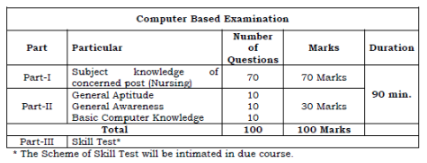

#### General English

* Substitution.
* Antonyms.
* Joining Sentences.
* Fill in the blanks.
* Passage Completion.
* Error Correction (Underlined Part).
* Sentence Improvement.
* Prepositions.
* Data Interpretation.
* Spelling Test.
* Active and Passive Voice.
* Sentence Completion.
* Synonyms.
* Error Correction (Phrase in Bold).
* Sentence Arrangement.
* Idioms and Phrases.
* Para Completion.
* Transformation.
* Spotting Errors.

#### Quantitative Aptitude

* Boats and Streams.
* Problems on Numbers.
* Odd Man Out.
* Compound Interest.
* Profit and Loss.
* Mixtures and Allegations.
* Simple Equations.
* Indices and Surds.
* Percentages.
* Numbers and Ages.
* Ratio and Proportion.
* Probability.
* Problems on L.C.M and H.C.F.
* Time and Distance.
* Problems on Trains.
* Areas.
* Volumes.
* Races and Games.
* Averages.
* Quadratic Equations.
* Mensuration.
* Permutations and Combinations.
* Pipes and Cisterns.
* Simple Interest.
* Time and Work Partnership.
* Simplification and Approximation.

#### Reasoning

* Analytical Reasoning.
* Logical Reasoning.
* Data Sufficiency.
* Non-Verbal Reasoning.
* Puzzles in Verbal Reasoning.
* Data Interpretation.

#### General Knowledge

* Indian History.
* Indian Culture.
* Sports.
* Zoology.
* Famous Days & Dates.
* Botany.
* Indian Politics.
* Physics.
* Indian Parliament.
* Basic GK.
* Chemistry.
* Geography.
* Environment.
* Indian Economy.
* Inventions in the World.
* Basic Computer.
* Famous Books & Authors.